Graphical representation

Of watching song & memo writing

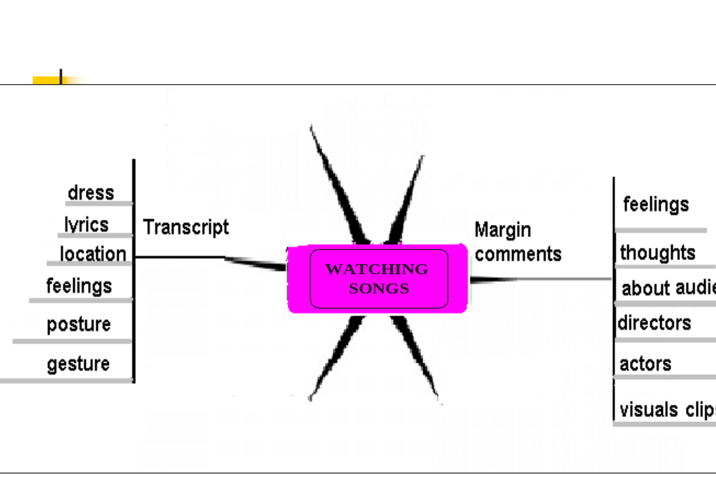

Graphical representation

Of watching song & memo writing

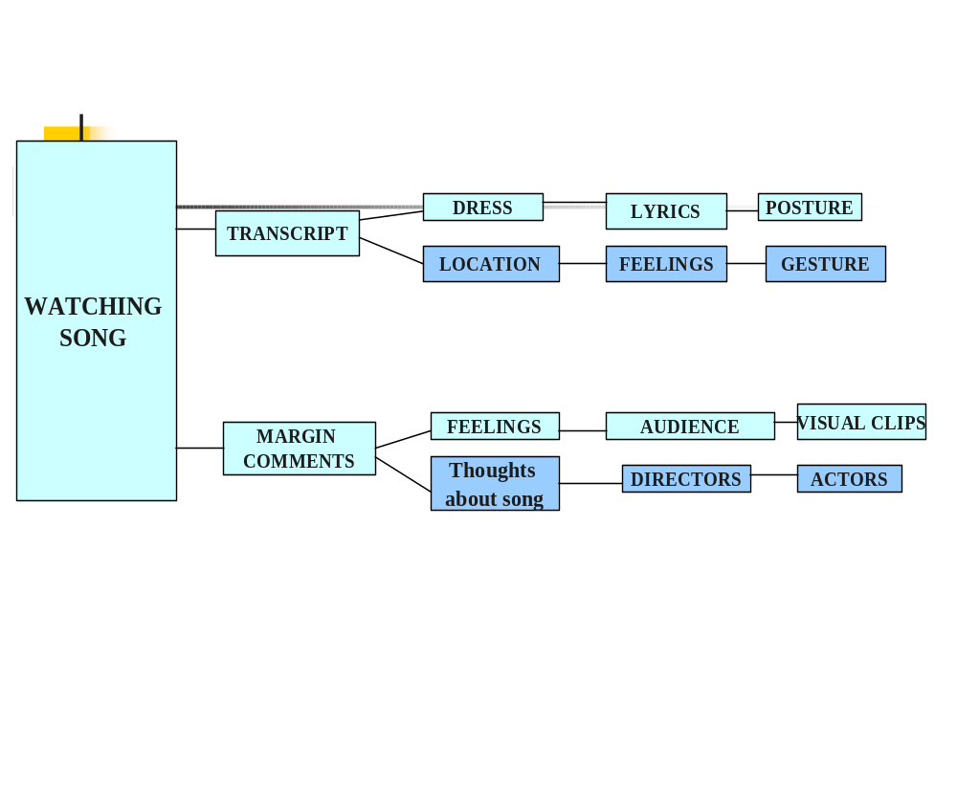

ABSTRACT

The current Research deals with an analysis of a film song. The method used to analyze the song was Memo Writing. Grounded Theory was generated after the analysis. The core purpose of the study was to investigate why a culturally inappropriate and vulgar approach has been adopted in Pakistani film songs. Also, why these practices are accepted and enjoyed by some members of the society. The issue of gender stereotype in the society was also explored. All these questions are answered in the form of theory. Four researchers (group members) of this study separately watched the song. The memo/ or note was taken during the viewing of the song. The next step after memo writing was cross comments writing i.e., each memo was read by each individual and generated 4 transcripts of comments based on the original memo readings. A final commented (Memo) was generated. Open coding was done on this transcript. And finally a theory was built on the bases of final concluding remarks. In the present study grounded theory is perfectly providing the base to enable us for the prediction and explanation of the behavior of performers, viewers, and makers of Pakistani film songs.

Introduction

Women have been badly exploited in Pakistani cinema for the past 53 years. Ever since the film industry was established they have been depicted in a vulgar, and cheap manner; exposing their bodies to please men, or shown as helpless and feeble.

Pakistani film heroines seem to have nothing to do with cinema except dancing to please their heroes. Men walk away with all the applause in the end because they are the ones who were the ultimate saviors. Women are shown to be largely depending on men for solving their problems and deciding their fate. (Ghor, F., 2005)

These things clearly represent the double standards of our culture; women are supposed to be chaste and decent in real life but on screen they are shown as teasers and a source of pleasure for men. It is a bitter fact that a woman has never been shown as a pilot, a decent teacher, a believable doctor or a hard-working agriculturist in a village. (Ahmad, K., 2004).

It is because the makers of these films are men who portray these women the way they like. The leniencies of the censor have allowed more vulgarity to enter into films, which is making the situation from bad to worse. The most alarming part of all this is the fact that the few female film directors of the country are also doing the same stuff.

One of the leading causes for the above mentioned situation is that there are very few women who go to cinemas to watch movies. This has been caused by many factors.

First of all, the proliferation of VCR's, cheaper fare on VHS cassettes, and the availability of more interesting and newer Indian and American films have caused a great number of women to remain at home and not go to cinemas.
Another contributing factor is the lack of entertainment for our
youth. You go to a movie theater and people make annoying noises
and suggestive comments, which makes it a stressful situation for
women, if the intent is to enjoy the movie. Even in theater, people in
the audience continually taunt the actresses and women in audience as well.
Almost in every audience whether it’s in theater or cinema, halls full of rowdy college students or any male crowd disturb the entire evening, for no other purpose but to get the attention of the women in the audience
Do Pakistani films represent Pakistani culture - well the answer to that is no, because the story lines are unrealistic and tend to be way over exaggerated. The Pakistani film industry needs to realize that they need to relate to the realistic lives of Pakistani people and the Pakistani culture if they want to see success (BBC, 2005).

The Pakistani cinema is today thriving on vulgar dances and nudity found in most of the Lollywood flicks. The Pakistani cinema is tagged as a crowd of such filmmakers who believe more in vulgar dances than a strong script.

The heroines from the senior’s regiment, especially Reema and Nargis, are always indulged into a high-voltage spree of vulgar dances. Both ladies have ‘decorated’ Pakistani film industry with some real vulgar dances they performed in various films (Ahmad, S., 2005).

Views were expressed by TV actress and director Faryal Gohar in her lecture on Women as depicted in electronic media at the British Council. Faryal started off by showing some slides of film photographs

and posters that show women in some very objectionable outfits and vulgar postures. She then went on to show clips from various films made in different eras comparing of songs and scenes that speak volumes of a woman's role in Pakistani cinema Faryal was of the view that a Pakistani film heroine had Nothing to do with cinema except dancing to please their heroes (The Dawn, 2001).

In qualitative content analysis of 150 popular films, the meaning of gendered conflict in contemporary popular culture is addressed from a systems theoretical perspective. Gendered conflict occupies a central position in these films and is normatively structured in terms of networks of romantic/sexual conflict based upon the geometric foundation of the triangle. Triangles are found to invoke dualistic pairs of stereotypes among characters who are competing for the attention of a common focus of attraction.
When men occupy the center of triangles, dualism involves the Madonna/Whore archetype. When women occupy the center, dualism alternates between Hero/Villain and Prince/Scoundrel archetypes. Norms, values, and expectations regarding gendered conflict are found to foster male privilege in each archetype (Hedley, M. 2000).

Steps of study

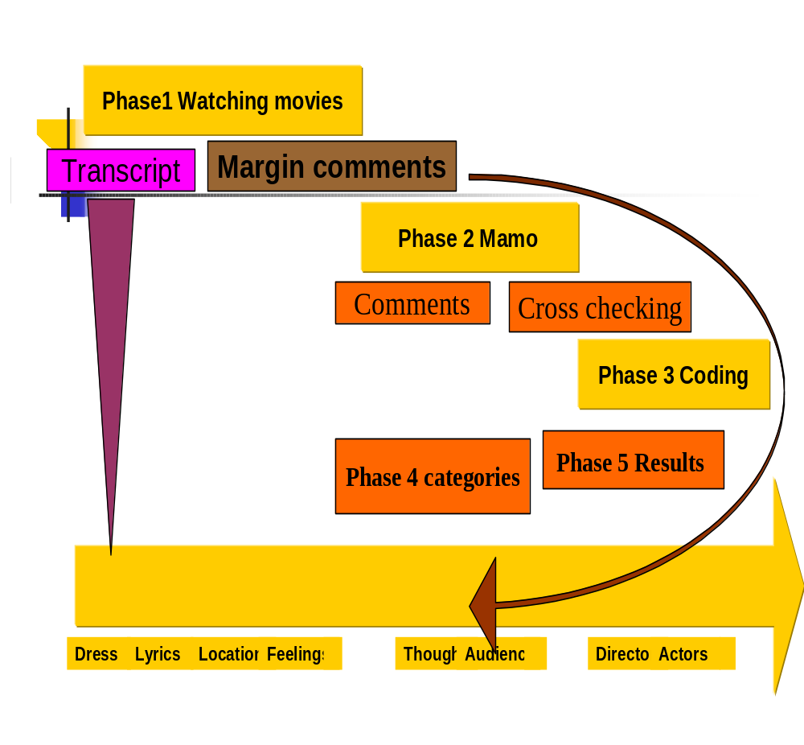

Methodology: -

The method used to analyze the song was Memo Writing. Grounded Theory was generated after the analysis.
The role of theory is:
- To enable prediction and explanation of behavior
- To be useful in theoretical advance
- To be useable in practical applications
- To guide research on behavior.

The core purpose of the study was to investigate why a culturally inappropriate and vulgar approach has been adopted in Pakistani film songs. Also, why these practices are accepted and enjoyed by some members of the society. The issue of gender stereotype in the society was also explored.

All these questions are answered in the form of theory. Four researchers (group members) of this study separately watched the song. The memo/ or note was taken during the viewing of the song. To transfer the song on paper in written from, whatever lyrics, dresses, locations, gestures and postures were coming on the screen were written down.

Margin comments were also written to utilize the thoughts, feelings, and expressions that came across when watching the songs.

The next step after memo writing was cross comments writing i.e., each memo was read by each individual and generated 4 transcripts of comments based on the original memo readings. A final commented (Memo) was generated. Open coding was done on this transcript. And finally a theory was built on the bases of final concluding remarks.

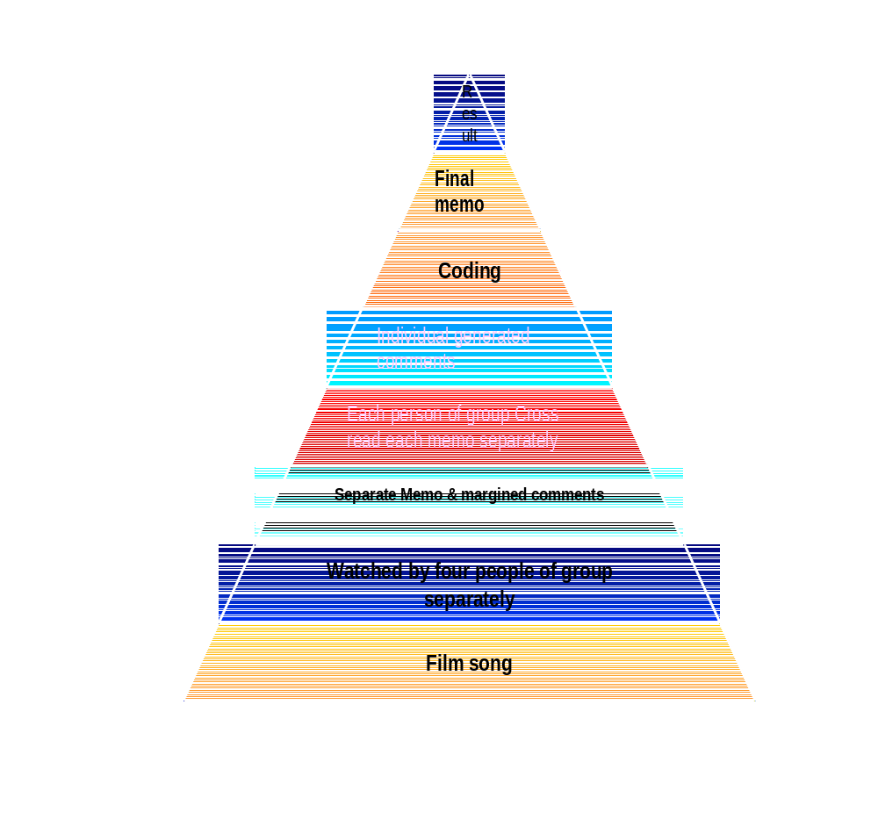

Step one

Selection of song

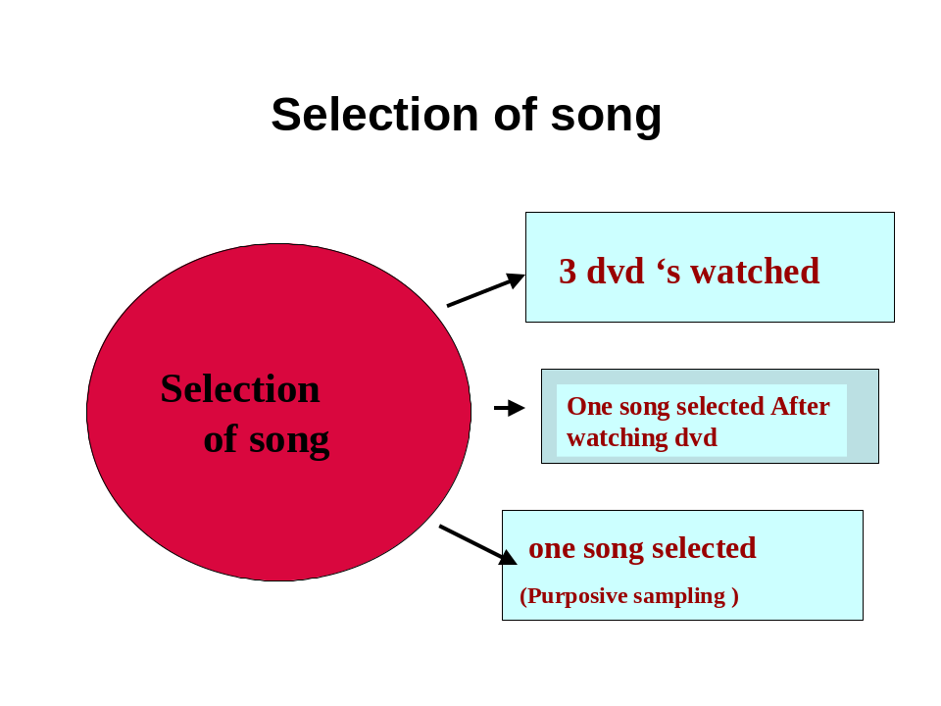

Step two

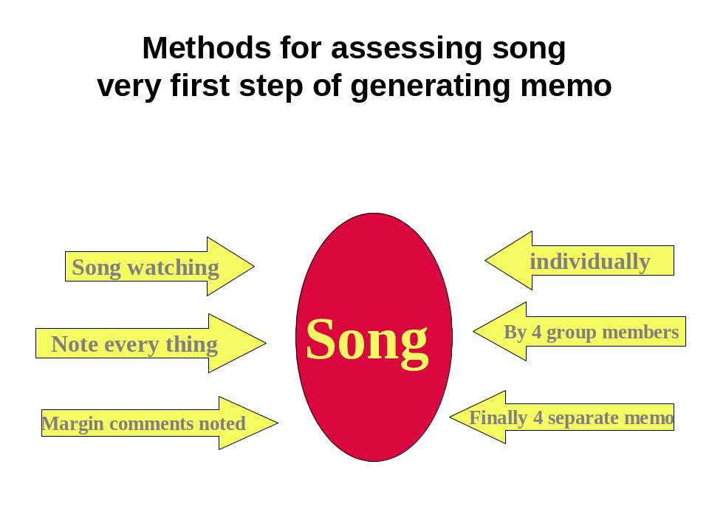

Results: -

Results were based on the final comments (Concluding memo).

- When people go for such kind of amusements, they are indirectly satisfying their needs and wishes.

- Especially youngsters find it the safest kind of pleasure seeking.

- The viewer of these songs mostly belongs to lower socioeconomic class and it is not easy for them to go to red light area. The viewers of these songs also want to line in fantasy world, where they share the status of a feudal as depicted in Pakistani films.

- The dualistic system of the society regarding men and women is a significant contributor.

- Males are considered superior and dominating, and same status is given to them in films. Where they are depicted as “all powerful” and oblivious to ladies, behaving in a rude manner.

- Vulgarity in film songs indicates that the makers are sublimating their own desires and wishes in the name of art.

- Another important contributing factor in the increased number of these practices may be a direct result of modeling i.e., people learn from others’ behaviors and outlooks. Thus the importance of one’s environment cannot be denied.

- The female point of view about these practices is not clear. There can be many factors that are contributing to the recent status:

- Mostly female actress, especially filmy heroines are from red area.

- Instead of being called “prosecutes” by the members of society, they prefer to be called actresses. Because in this way, there is less blaming and more praise.

- Considering the female role is the society, it can be assumed that film heroines may adopt this vulgarity due to financial reasons. As long as their career provides them financial security, they do not bother about the moral aspect of their work.

- The fact that their vulgar acting does make the film actresses popular (though in limited circles), and brings fame, also promotes their approach.

- For those females, who belong to the Red light area, film songs provide a substitute or extension of mujra. It becomes an acceptable and affordable from of mujra.

- Now, cinema becomes a women excluded place, because the attitude of male audience towards female performers, and also to female audience, is demeaning.

- These film songs depict a stereotype male representation of females: as passive, submissive and shameful. This outlook has resulted in an increased involvement of the young generation in female harassment or child sexual abuse.

- These films are not representative of our true Punjabi culture.

- In fact like many other things, in this case we are again influenced by Indian culture; where no respect is given to females.

These Songs are 3-way partnership
Audience, Actors & Directors

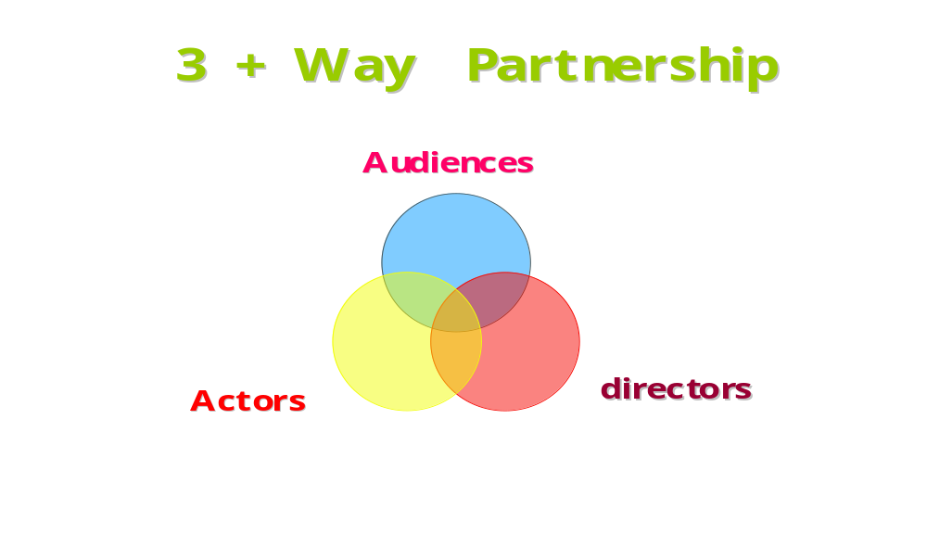

Diagram showing results

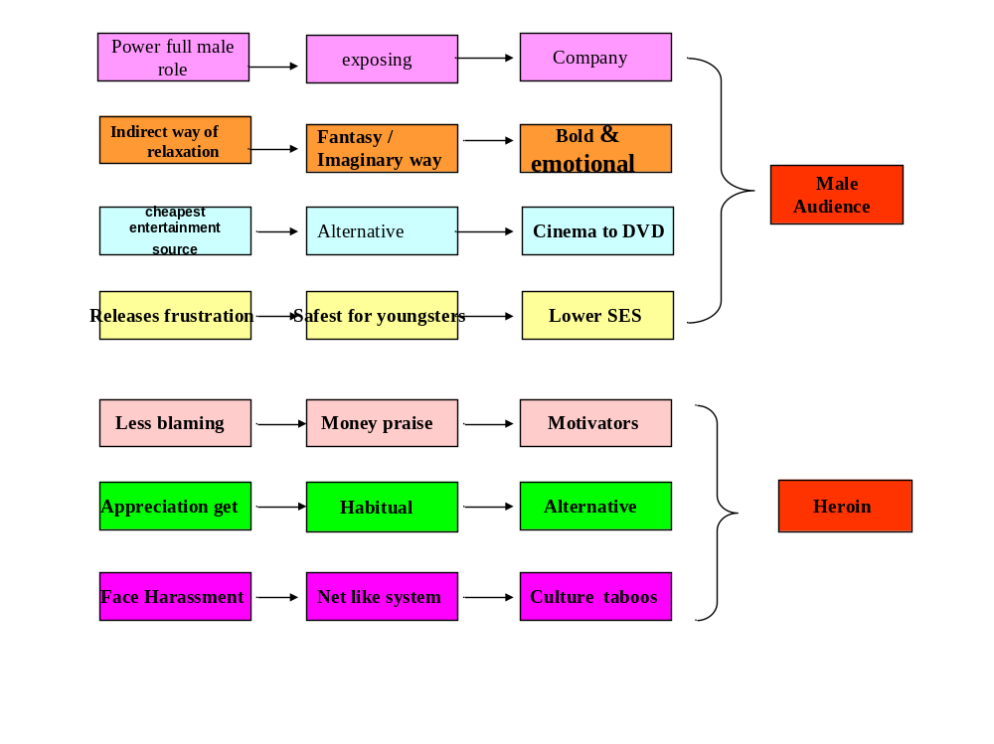

Results
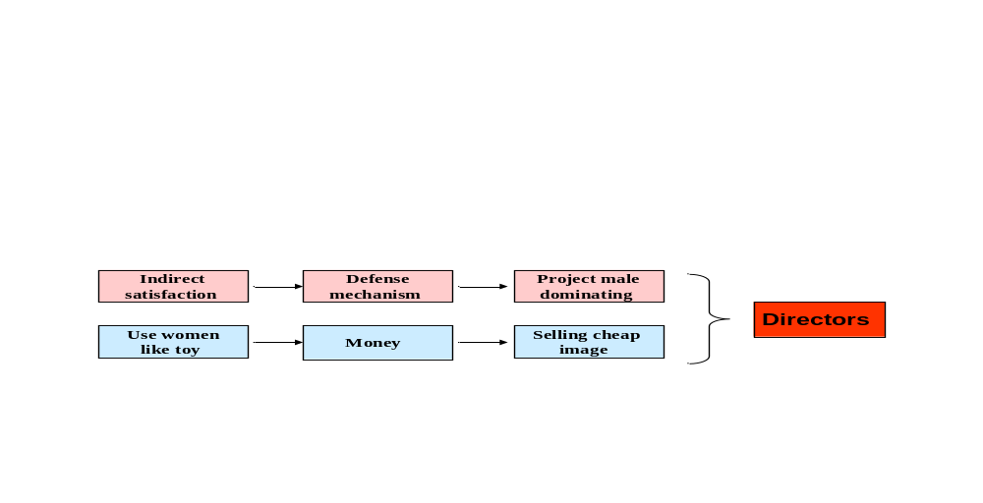

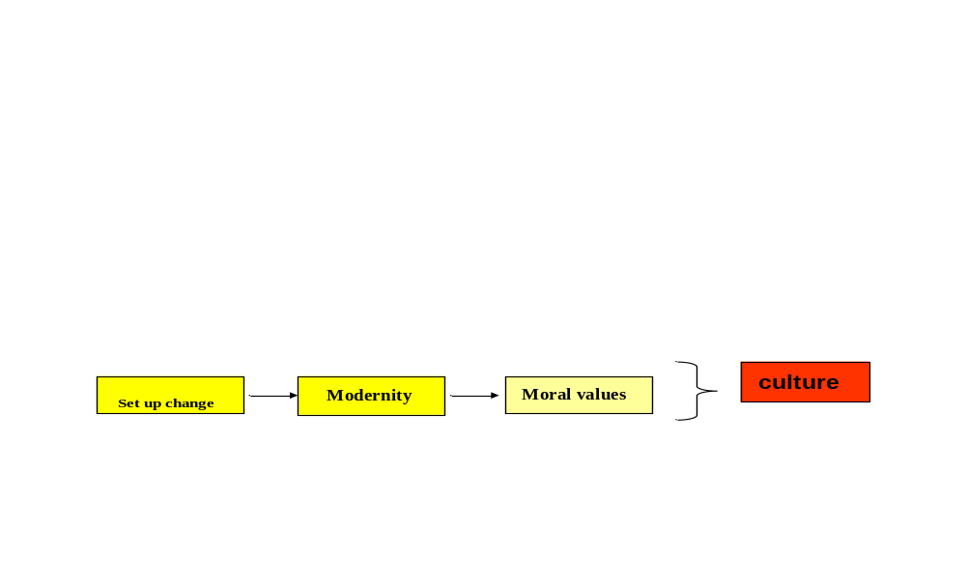

Sublimation

Defense mechanism
Psychoanalytic

Factors associated filmy culture

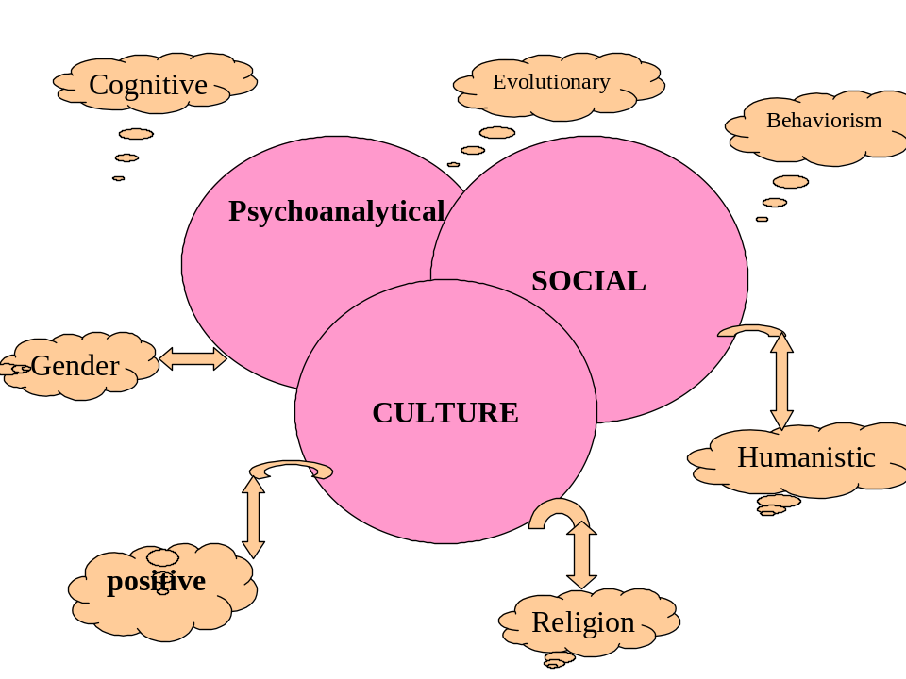

Portrayal of heroine in (Punjabi) cinema

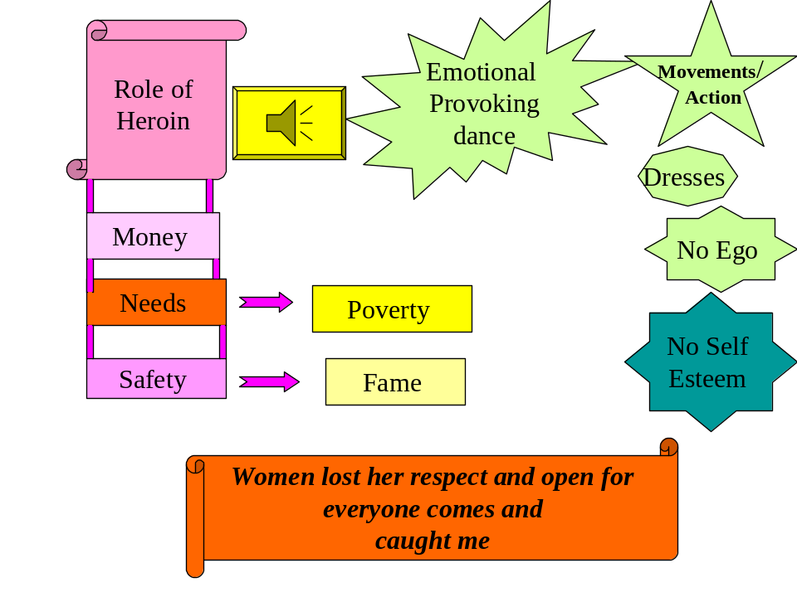

Impact on audiences

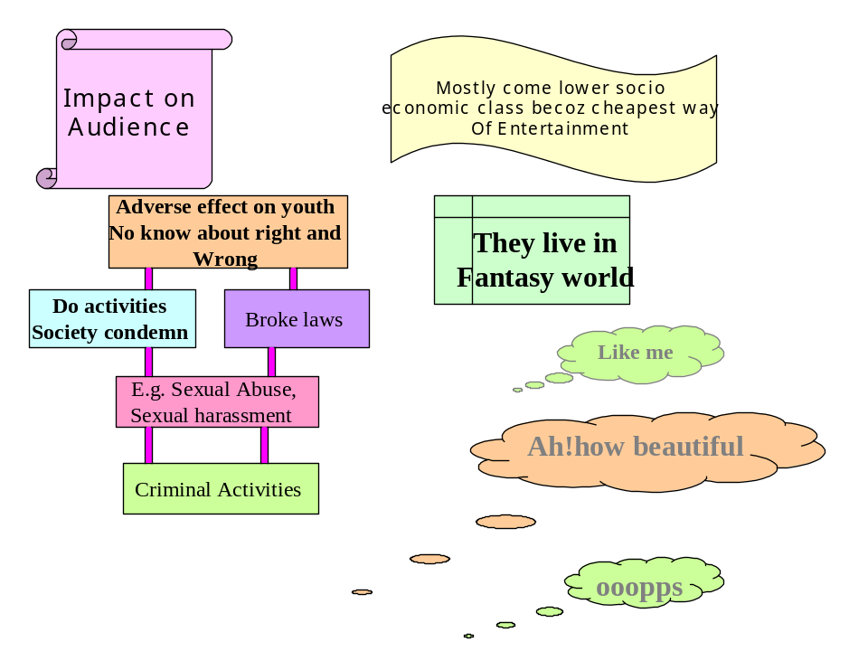

Women used as toy in cinema

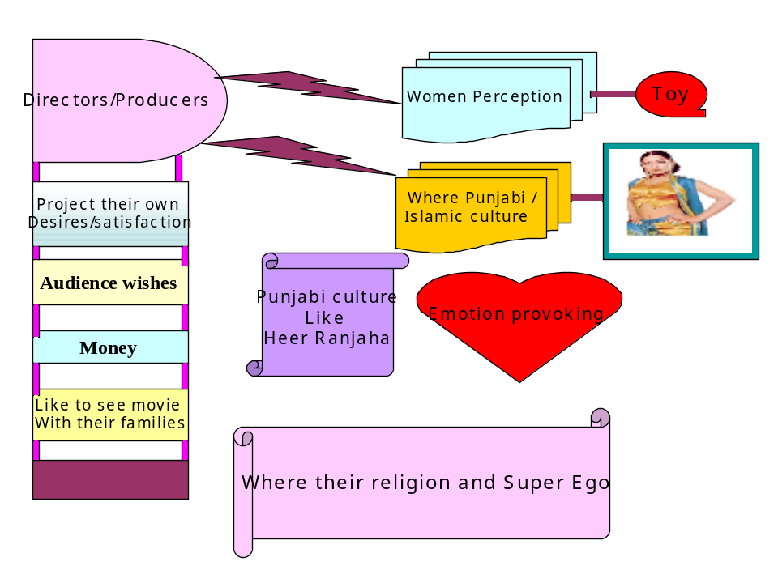

Mujra to cinema, cinema to theater
& Excluded space for women

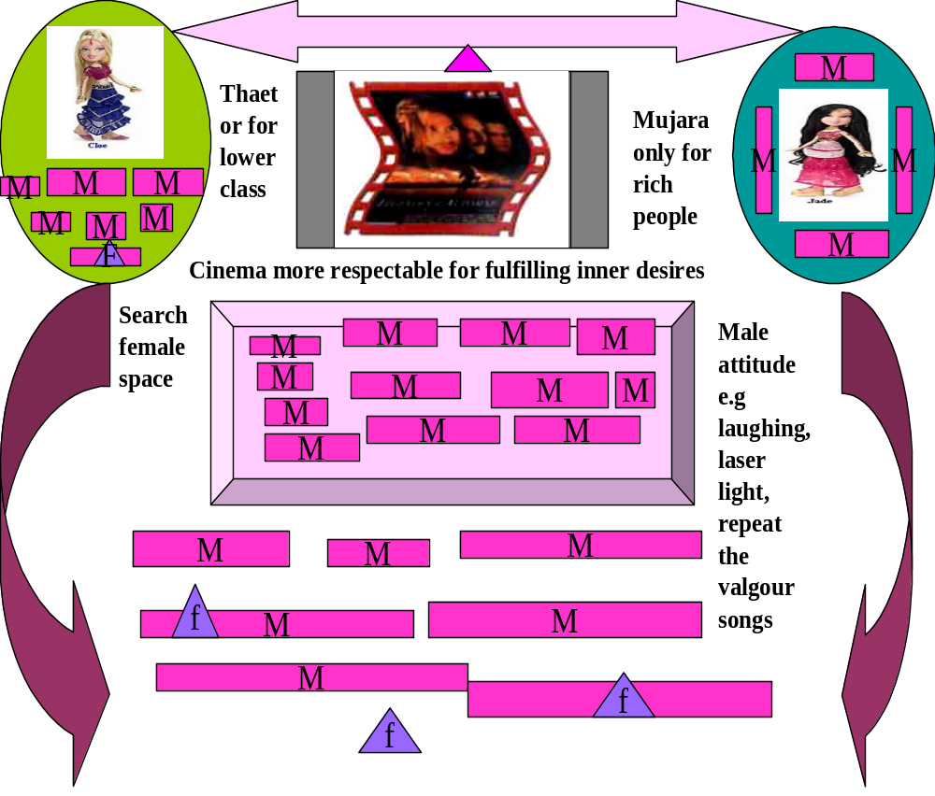

Discussion

The present study was carried out with the questions that why Pakistani film songs depend heavily on vulgarity and male domination; why men in these songs are depicted as disrespectful and ill-mannered towards women; why females are depicted as very passive and dishonorable persons who seem to have no business except pleasing their men at any cost; and last but not the least, why such values are portrayed when they are a long way from our real culture.

The qualitative nature of the study helped in reaching to certain conclusions as mentioned above in the results. First of all, the results show that males are depicted in Pakistani film songs as dominant and oblivious of women. This situation actually exists in our society, though not on as large a scale as depicted in film songs. The male in our society is supposed to be the ruler in the family, and having control over women is considered a positive personality trait. So no wonder that filmmakers make every effort that their hero look and behave like a “real man”.

This trend has led the average male person in the society to also adopt the same attitude towards women. The rudeness of the male hero in the film is copied by the viewers especially the young who imagine themselves as powerful as the film hero. Also this trend is the root cause in the rapid increase of crime in the society.
Another important point that comes forward is that women of film industry do not represent the women of the real society. As far as this issue is concerned, there can be various reasons for it. For example, that most of the women in the Pakistani film industry belong to red light areas is a ground reality. There is no question of morality for these women in the first place. In fact they perceive every shameful act as amplifying their commercial “value”.

Then the role of media is another dilemma: the media does every effort to promote the film stars who involve themselves in bold and shocking performances on the screen. This is largely done for commercial purposes.

On the part of the general viewers, it can be said that most of them go to watch such movies and songs because they do not have any other choice. After all, it is the low socio-economic class that contains the largest viewer ship of these movies. They pursue a way out for their frustrations and economic pressures and get relaxation; and watching movies is indeed a cheaper way of entertainment.

Also they often tend to identify with the hero who is depicted as a powerful personality. Having limited resources, the ordinary man perceives the actions of the hero as projections of his own inner feelings and desires. This leads to ego satisfaction in him. Though this view does make much sense, the quality of the movies in general and the film songs in particular, depend largely on the choice of the filmmaker, and not on the viewers.

The filmmakers in Pakistan also do not belong to the general society; they are mostly rooted in red light areas, or carry similar backgrounds. Having access to money and resources, they tend to fulfill their own desires while making movies. But, of course, they keep in view their business aspects as well: their profit making. As a result, the cinema has become a female excluded place rather family entertainment place.

Coding
Categories

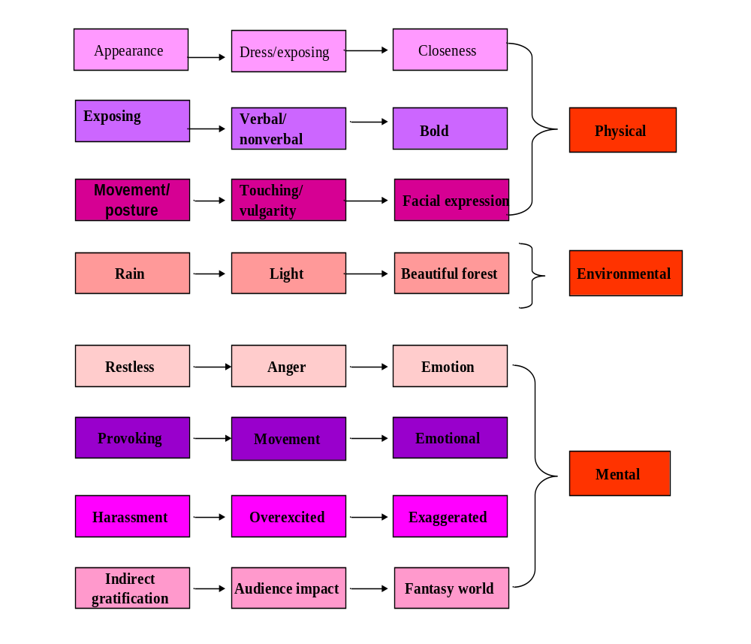The above theory was formulated after the analysis of results. It can be named “the Theory of Media Decline”, or “Media Decline Theory”.

Conclusion:
When in a society the primary focus of media shifts from art & entertainment to pure profitability; it results in deterioration in the quality of productions.

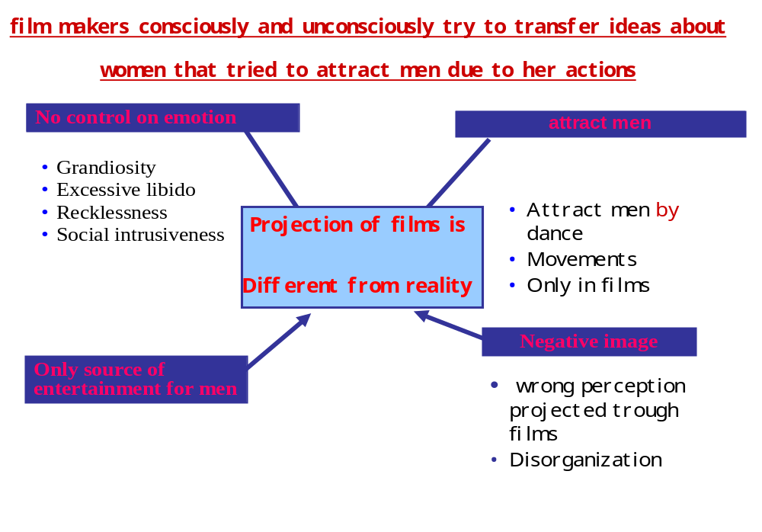
Shift of sources through time

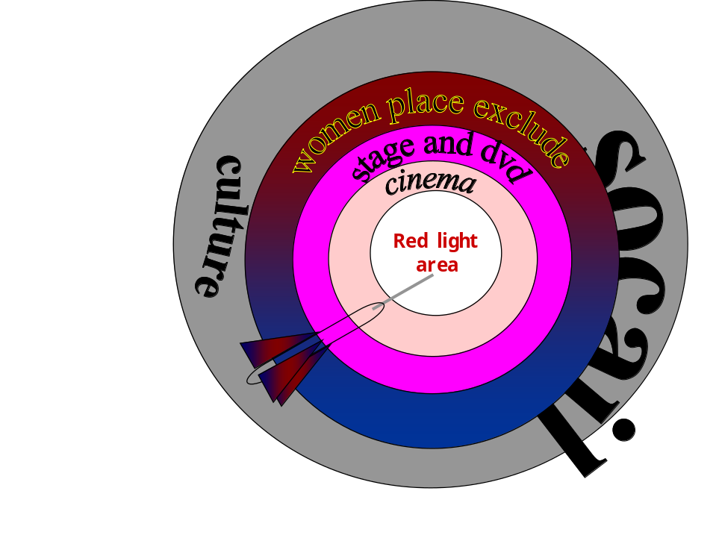

Ratio of male & female

Audience in cinema

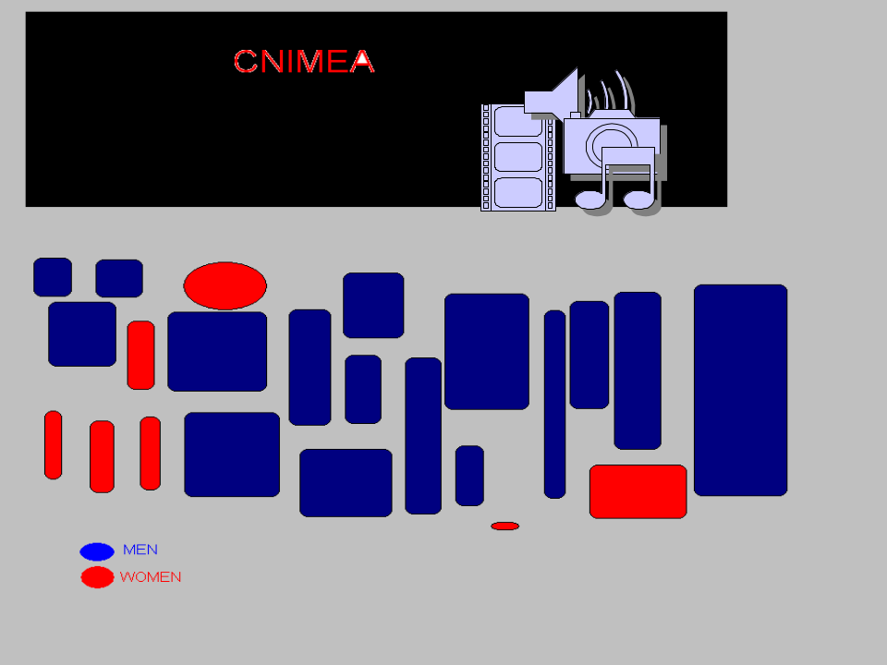

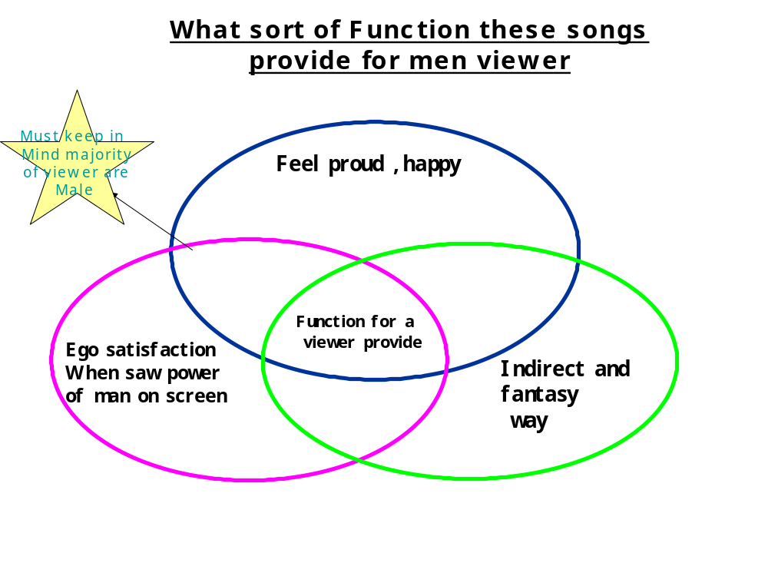

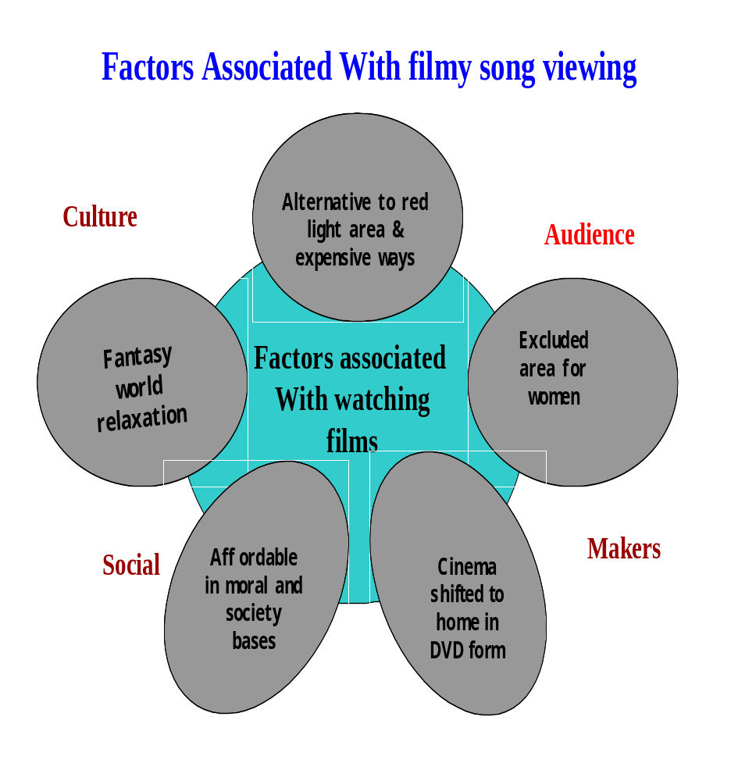

Social & psychological
Factors associated in film viewing

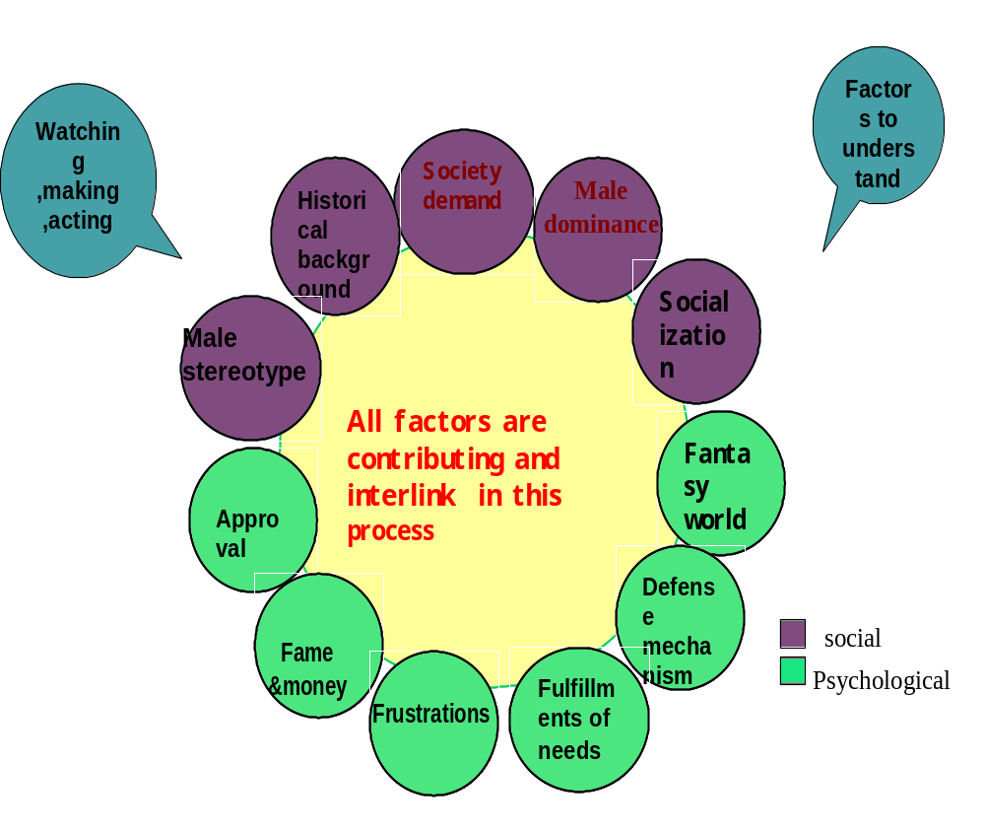

Male dominance represents in
Postures
& Props they used in films

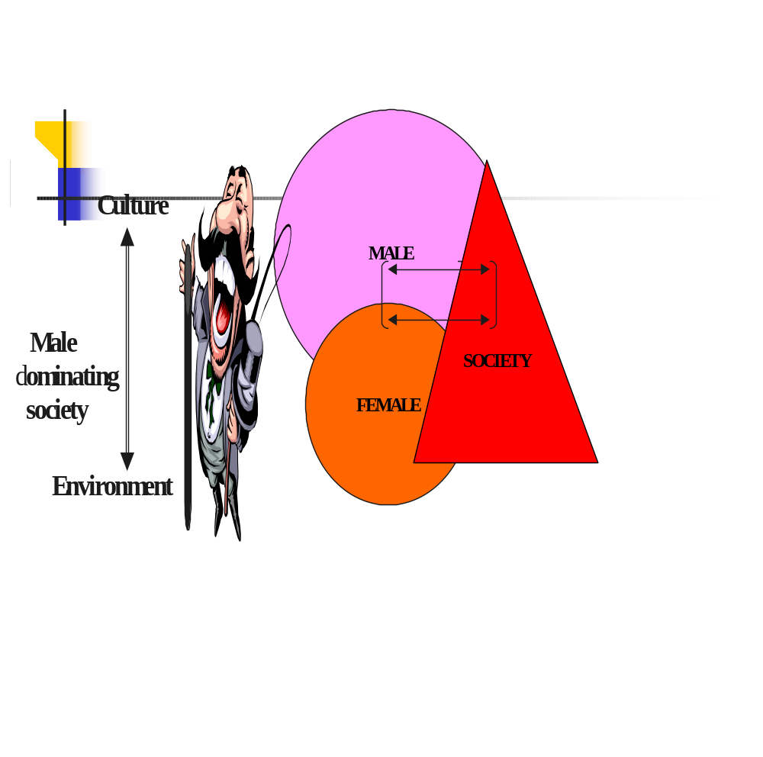

Male role in reality &films

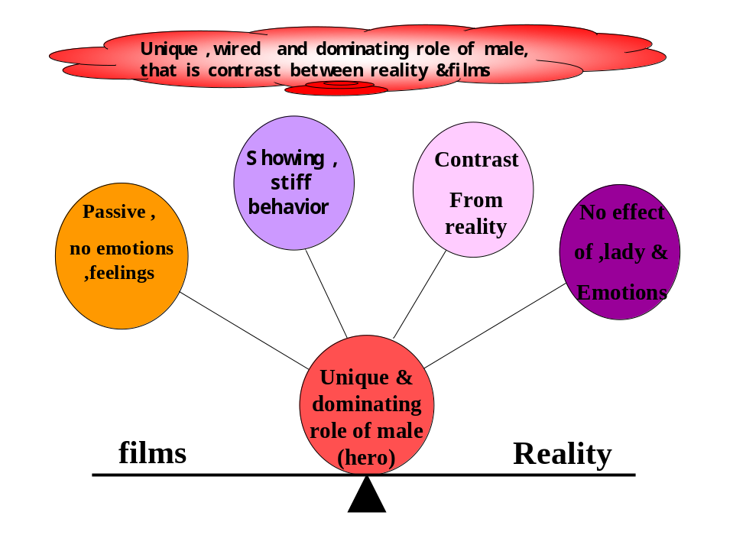
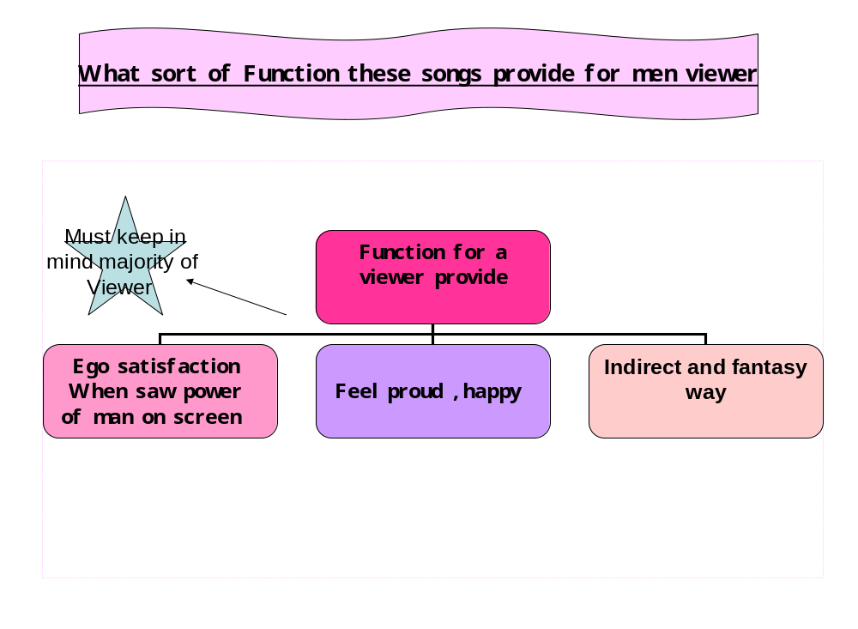

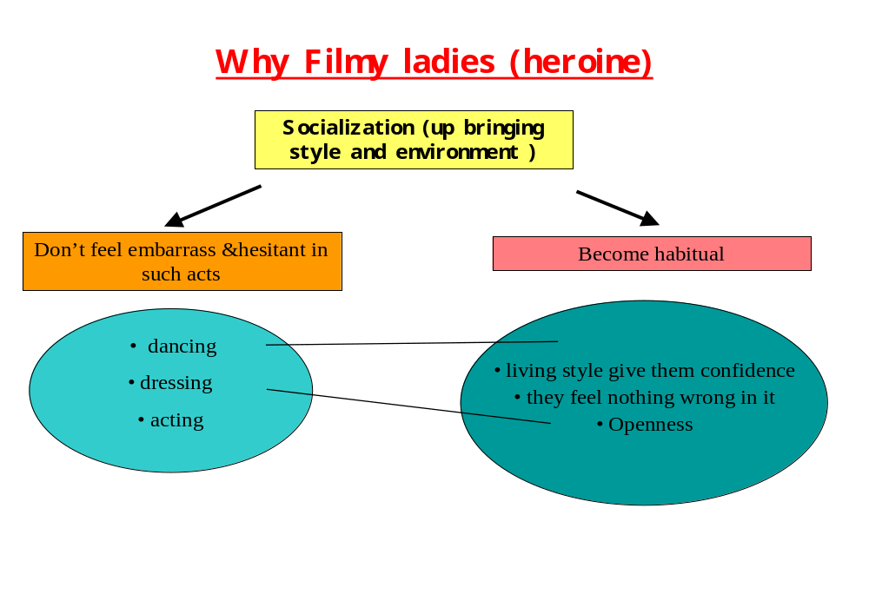

What we need in Pakistan is more emphasis on the development of moral and ethical values. There should be more co-education institutes, so that men and women can be socialized with each other at an early age, and not acquires this attention seeking, impress-the-other-sex chauvinism.
Also, the government must enforce a stricter censor policy regarding these film songs.

References:

Gohar, F. (2001 Mar 22). Exploitation of women in films. soc_culture_pakistan.
Retrieved March 20, 2006, from
http://groups.google.com/groups?as_umsgid=3ab9b85e@news-
uk.onetel.net.uk...
Karandikar, V. (1992). Ladies in Cinema Halls soc.culture.pakistan
Retrived March 24, 2006, from hj.htm<1992Sep19.230102.18210@engr.uark.edu>
1992Sep24.014725.29131@cronkite.ocis.temple.edu.

Khan, M. (2003). PAKISTANI CINEMA, Bolly What presents an INTRODUCTION TO
LOLLYWOOD, THE PAKISTANI FILM INDUSTRY.htm.RetrivedApril12from
http://www.lollywood.pk/http://www.thehotspotonline.co/p

H:\FIL\Women, Islam and Cinema - Google Book Search.htm
http://books.google.com/books?id=pWhZ0hgH80cC&pg=PA6&lpg=PA5&dq
=stereotypes+about+pakistani+film+heroine&sig=_pj8ko2U16VWM_nTFfCP

